Please see the two paragraphs below, share them with your Post’s and/or any veteran you know that might benefit from this information.
Travel Reimbursement – A recent VA IG Reported this as a significant problem across the country. “Goals Not Met for Implementation of the Beneficiary Travel Self-Service System” https://www.va.gov/oig/pubs/VAOIG-21-03598-92.pdf. The bottom line is switching the system from the terminals at the Hospital to online only is not working. There will be more information to follow.
PACT Act – The deadline to file a new claim, or to have an existing claim reviewed and have it backdated to the date the PACT Act was signed, is August 10th. If filed by this date any claims will be backdated. If the claim is filed after August 10th, you will only receive payment from the date you filed. So, if you are considering filing under the new presumptive in the PACT Act it be financially beneficial for you to do it before August 10th.
If you have any questions, please don’t hesitate to contact me.
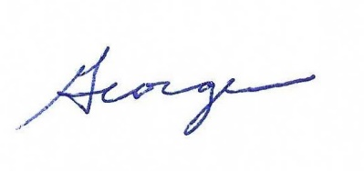
George W. Smith
ALRDOC Service Officer

