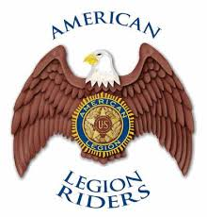
The American Legion Riders
Department of California
www.alrdoc.org

President: Mick Sobczak Secretary: Debbie Proffitt

Mick Sobczak
American Legion Riders
Department of California
1601 7th. St., Sanger, CA 93657

December 7, 2018
NAME
Title
Company
Address1
Address2

Dear Mr. / Ms.,
I am writing to you on behalf of The American Legion Riders, Department of California, a 501(c)19 wartime veterans service organization that is working for the support of veteran’s issues, their families, and our communities. Currently, The American Legion Riders supports The American Legion Legacy Scholarship Fund, which provides college scholarships the children of service members who were killed in action or combat wounded while serving this great nation. Our organization is dedicated to the process of making this happen but we need your help.
For every $20,000 donated, we are able to provide one of these children a one-year college scholarship. We are also one of the only scholarship programs which provides scholarships for up to six years, allowing these children to obtain a Master’s Degree. Your donation will bring us closer to our goal of $200,000. Many business and community leaders are on board as well as hundreds of individuals. Our veterans and communities are clearly excited and eager to see this succeed. You can be a part of that excitement by supporting our veterans and their families with your donation. We are happy to acknowledge your donation on our website and at our numerous events throughout the state of California.

I would like to thank you for considering this opportunity to support our organization for raising funds. If you have any queries regarding our organization, our fund management policy, or these programs themselves, please feel free to contact me at the address given above or at president@alrdoc.org.
Please mail all checks to:

American Legion Riders
Department of California
ATTN: Department Treasurer
PO Box 509
Temecula, CA 92589

Thank you for your generosity,
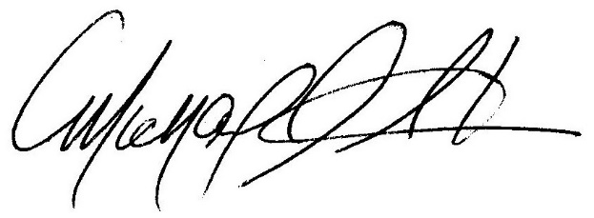
Mick Sobczak

